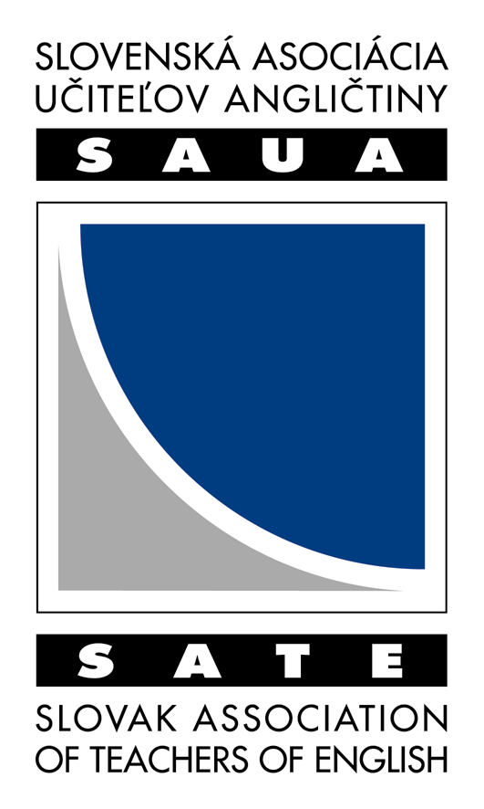
SLOVENSKÁ ASOCIÁCIA UČITEĽOV ANGLIČTINY
SLOVAK ASSOCIATION OF TEACHERS OF ENGLISH

ČLENSKÁ PRIHLÁŠKA
MEMBERSHIP APPLICATION FORM

Priezvisko / Surname ...........................................................................................................................

Meno / First name .......................................................................Titul / Title .....................................

Angličtinu učím/študujem / I have been teaching/studying English for ……………….. rokov/years.

Bydlisko/ Home address
Ulica a číslo/ Street&number ...............................................................................................................
PSČ a obec/ ZIP Code &Town ............................................................................................................
Telephone ............................................................................................................................................
E-mail ..................................................................................................................................................

Adresa pracoviska/školy / Place of work/school
Inštitúcia / Institution ...........................................................................................................................
Ulica a číslo/ Street&number ...............................................................................................................
PSČ a obec/ ZIP Code &Town ............................................................................................................
Telephone ............................................................................................................................................
E-mail ..................................................................................................................................................

Membership dues are as follows:
(Circle one amount below):

Regular member: 10 EUR Student member: 5 EUR

Special Interest Group (Circle 1 or 2)
Membership includes the choice of one free SIG.
Fee for one or more SIGs is 2 EUR per year for every other.

Young Learners ESP Testing Drama

Please pay the fee to the account of SAUA/SATE,
SLSP. a.s No 11485912/ 0900
Konšt.symb.0379
Var. symbol 2012

Your cancelled check is your receipt. Send this form and copy of your check to:
Božena Hrubčínová, Tupolevova 10, 851 01 Bratislava
or to e-mail: bhrubcinova@stonline.sk

_______________ ________________
Date Signature

